SVKM’s NMIMS

MPSTME

Computer Engineering Department (MCA SEM I)

Web Programming

Lab Manual

**PART A**

(Part A: TO BE REFFERED BY STUDENTS)

**Experiment No. 07**

**PART-A**

**A.1 Aim:** Creating Web application with Bootstrap (Sample given in the image)

1. Module:

* Imagine you are an online tutor and you give online courses on html css javascript
* First create a responsive web page with grid layout for all devices. In the first row create only 1 column and write about your online tutoring class
* In the second row create 3 columns, one for html, css and java script explaining about each course
* Use bootstrap jumbotron, Dropdowns, Buttons as per the design and content

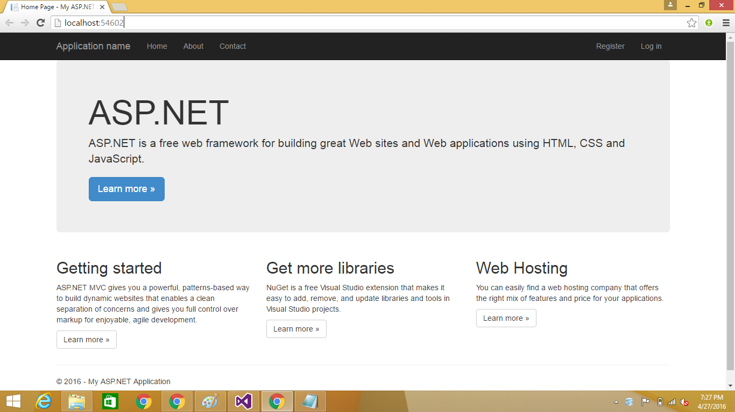

2. Module: Create a webpage layout with bootstrap as given in the image here. (Use bootstrap grid, buttons, images)

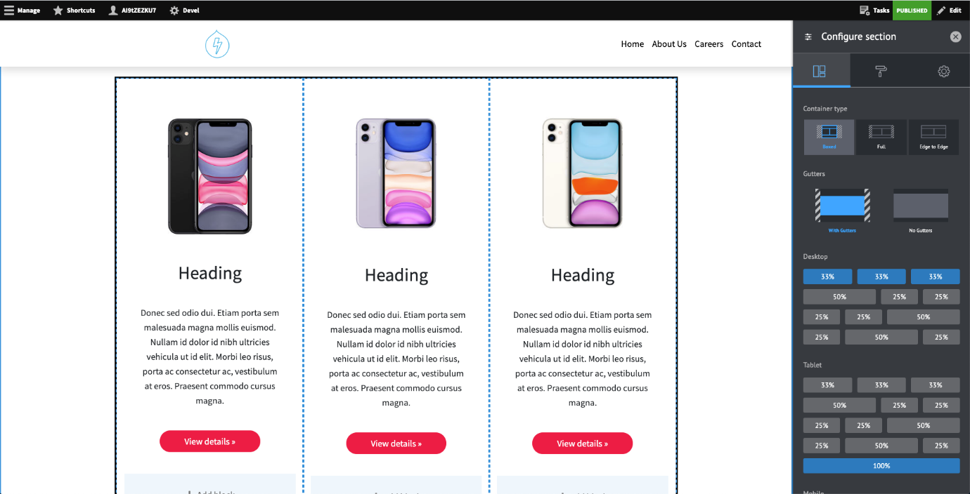

Module 3: Create a responsive table as shown below

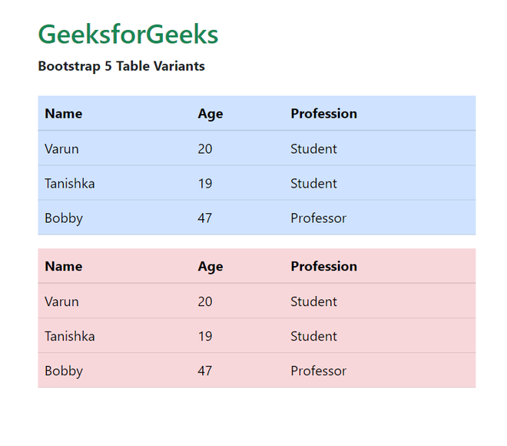

Module 4:

**A.2 Prerequisite:**

HTML, CSS ,Javascript

**A.3 Outcome:**

After successful completion of this experiment students will be able to

1. Understand and build web application with Bootstrap

**A.4 Theory:**

* Bootstrap is a free front-end framework for faster and easier web development
* Bootstrap includes HTML and CSS based design templates for typography, forms, buttons, tables, navigation, modals, image carousels and many other, as well as optional JavaScript plugins
* Bootstrap also gives you the ability to easily create responsive designs(websites which adjust themselves depending on the device)
* Many of these use JavaScript extensions and jQuery plugins
* Step 1: Install Bootstrap or include Bootstrap CDN in the web page (**See Lecture Slides**)
* Step 2: (**See Lecture Slides**)
  + WE write
    - CSS file name (in the head)
    - JS file name (just before closing body)
    - Jquery file name (just before closing body)
* Bootstrap also requires a containing element to wrap site contents.
* There are two container classes to choose from:
  + The .container class provides a responsive fixed width container
  + The .container-fluid class provides a full width container, spanning the entire width of the viewport
* Step 3:
* Grid systems are used for creating page layouts through a series of rows and columns
* Rows must be placed within a **.container** class for proper alignment and padding.
* Use rows to create horizontal groups of columns.
* Content should be placed within the columns, and only columns may be the immediate children of rows.
* Rows has attributes: xs, sm, md, lg
* Sample code

<!doctype html>

<html lang="en">

<head>

<!-- Required meta tags -->

<meta charset="utf-8">

<meta name="viewport" content="width=device-width, initial-scale=1">

<!-- Bootstrap CSS -->

<link href="https://cdn.jsdelivr.net/npm/bootstrap@5.0.2/dist/css/bootstrap.min.css" rel="stylesheet" integrity="sha384-EVSTQN3/azprG1Anm3QDgpJLIm9Nao0Yz1ztcQTwFspd3yD65VohhpuuCOmLASjC" crossorigin="anonymous">

<title>Hello, world!</title>

</head>

<body>

<h1>Hello, world!</h1>

<!-- Optional JavaScript; choose one of the two! -->

<!-- Option 1: Bootstrap Bundle with Popper -->

<script src="https://cdn.jsdelivr.net/npm/bootstrap@5.0.2/dist/js/bootstrap.bundle.min.js" integrity="sha384-MrcW6ZMFYlzcLA8Nl+NtUVF0sA7MsXsP1UyJoMp4YLEuNSfAP+JcXn/tWtIaxVXM" crossorigin="anonymous"></script>

<!-- Option 2: Separate Popper and Bootstrap JS -->

<!--

<script src="https://cdn.jsdelivr.net/npm/@popperjs/core@2.9.2/dist/umd/popper.min.js" integrity="sha384-IQsoLXl5PILFhosVNubq5LC7Qb9DXgDA9i+tQ8Zj3iwWAwPtgFTxbJ8NT4GN1R8p" crossorigin="anonymous"></script>

<script src="https://cdn.jsdelivr.net/npm/bootstrap@5.0.2/dist/js/bootstrap.min.js" integrity="sha384-cVKIPhGWiC2Al4u+LWgxfKTRIcfu0JTxR+EQDz/bgldoEyl4H0zUF0QKbrJ0EcQF" crossorigin="anonymous"></script>

-->

</body>

</html>

* Following is basic structure of Bootstrap grid −

<div class = "container">

<div class = "row">

<div class = "col-*-*"></div>

<div class = "col-*-*"></div>

</div>

<div class = "row">...</div>

</div>

<div class = "container">

....

</div>

**PART B**

**(PART B: TO BE COMPLETED BY STUDENTS)**

**(Students must submit the soft copy as per following segments within two hours of the**

**practical. The soft copy must be uploaded on the Blackboard or emailed to the concerned**

**lab in charge faculties at the end of the practical in case the there is no Black board access**

**available)**

**B.1 Software Code written by student:**

**(Students must paste the code here)**

**B.2 Output**

*(Take screen shots of the output at run time and paste it here)*

**B.3 Conclusion:**

*(Students must write the conclusion as per the attainment of individual outcome listed above)*

**B.3 Observations and Learning:**

*(Students must write their observations and learnings as per the attainment of individual outcome listed above)*

**B.4 Question of Curiosity**

*(To be answered by student based on the practical performed and learning/observations)*

Q1. What are Bootstrap components? Can you name a few?

Q2. What are Bootstrap modals, and how can you implement one?

Q.3 How can you customize Bootstrap’s default styles?

Q.4 Explain the difference between Bootstrap 4 and Bootstrap 5.

Q.5 Describe how responsive design is achieved in Bootstrap.